University of Cebu-Banilad

College of Computer Studies

# **HEALTHSHAPERS**

IT-ELDROID 1

84155 Friday (7:30 – 10:30 AM)

Submitted by:

Charles Brexie T. Saturinas

Jay Esplaguera

Dominic Restauro

Butch Nino Butas

Kevin Cachero

William James Janohan

IT-ELPHP

84193 Saturday (7:30 – 10:30 AM)

Submitted by:

Charles Brexie T. Saturinas

Dominic Restauro

Jay Esplaguera (Alliance)

Jessalyn C. Sadili

Fretch Barbie H. Hugo

Submitted to:

Mr. Richyll Son

**HealthShapers Project Documents**

**HealthShapers:** Is an innovative food donation application designed to bridge the gap between surplus food and those in need. Our platform connects businesses, restaurants, and individuals looking to donate excess food with local charities and food banks.

**ERD**

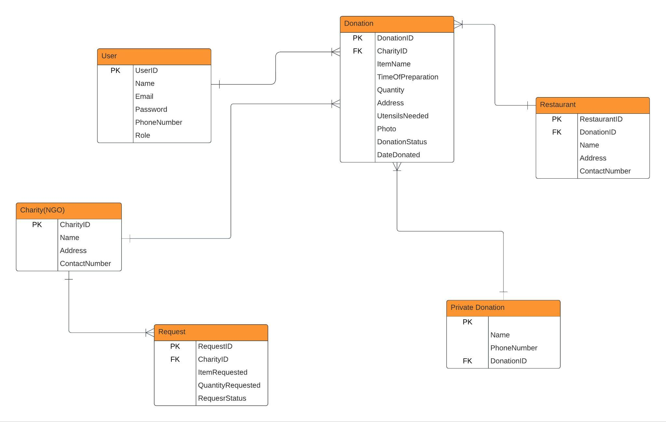

# 

# 

# 

# **Use Case Diagram**

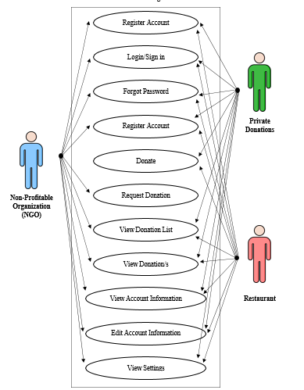

# 

# Figure 2: The Health Shapers use case diagram illustrates the interactions between key actors—NGOs/Food Banks, Restaurants, and Private Donations—within the system. NGOs/Food Banks view available donations, request or claim food, and confirm receipt. They can also manage donation history and leave feedback for donors. Restaurants and Private Donations can register, log in, list surplus food for donation, and coordinate pickups, while receiving notifications on donation status.

# 

# 

# 

# 

# 

# 

# **UI DESIGN**

| **Splash Screen** | | |
| --- | --- | --- |
|  | | |
|
|
|
|
|
|
|
|
|
|
|
|  | **Description** | **Parameter** |
| App Logo | HealthShapers app logo |  |

| **Login Screen** | | |
| --- | --- | --- |
|  | | |
|
|
|
|
|
|
|
|
|
|
|
|  | **Description** | **Parameter** |
| App Logo | HealthShapers app logo | image |
| Login Text | Login word text display | text |
| Email Input | Login input edit text | email |
| Password Input | Password input edit text | password |
| Remember me checkbox | Clickable for automatically filling out the Login input and password input | checked |
| Forgot Password | Clickable forgot password text display | new password |
| Login Button | Signing in the user to use the application features | login action |
| Don’t have an account? Sign up | Clickable for registering an account | text |

| **Register Screen** | | |
| --- | --- | --- |
|  | | |
|
|
|
|
|
|
|
|
|
|
|
|  | **Description** | **Parameter** |
| Register Text | Register word text display | text |
| Username Input | Username input edit text display | Username |
| Cell Phone Number Input | Cell Phone number input edit text display | Phone Number |
| Email Input | Email input edit text display | Email |
| Password Input | Password input edit text display | Password |
| Register Button | Registers the user with the form information | Button |
| Already have an account? Sign in | Clickable for directing the user to the login screen | Button |

| **Forgot Password Screen** | | |
| --- | --- | --- |
|  | | |
|
|
|
|
|
|
|
|
|
|
|
|  | **Description** | **Parameter** |
| Forgot Password Text | Forgot password text display | text |
| Email Address Input | Email address input edit text | Email |
| Send link button | Clickable for sending information to the email | Button |

| **Dashboard Screen** | | |
| --- | --- | --- |
|  | | |
|
|
|
|
|
|
|
|
|
|
|
|  | **Description** | **Parameter** |
| Image | Your profile image | image |
| Name | Name of donator | text |
| Donate | Press the button to donate | button |

| **Food Details Screen** | | |
| --- | --- | --- |
|  | | |
|
|
|
|
|
|
|
|
|
|
|
|  | **Description** | **Parameter** |
| Food Details Text | Food Details Text Display |  |
| Item Name | Name of the item that you donate |  |
| Preferred Time | Time for item arrival | datetime |
| Date | Date for item to be donated | datepicker |
| Quantity | Number of item to be donated | int |
| Address | Location where the donation will be dropped off or picked up | string |
| Food Image | Item image to be donate | image |
| Submit Button | To submit the item | Button |

| **Live Donations Screen** | | |
| --- | --- | --- |
|  | | |
|
|
|
|
|
|
|
|
|
|
|
|  | **Description** | **Parameter** |
| Dashboard Text | Dashboard text Display | text |
| Item Description | List of items donations | text |
| Confirm Button | Item to be donate | Button |

| **Your Donations Screen** | | |
| --- | --- | --- |
|  | | |
|
|
|
|
|
|
|
|
|
|
|
|  | **Description** | **Parameter** |
| Item Description | List of items donations complete/declined | text |

| **Donation List Screen** | | |
| --- | --- | --- |
|  | | |
|
|
|
|
|
|
|
|
|
|
|
|  | **Description** | **Parameter** |
| Item List | A detailed list of items to be donated |  |

| **Settings Screen** | | |
| --- | --- | --- |
|  | | |
|
|
|
|
|
|
|
|
|
|
|
|  | **Description** | **Parameter** |
| Edit Profile | Edit profile information |  |
| About | Information about the application | text |
| Terms & Privacy Policy | Service and privacy practices to understand how applications protect your data and ensure a safe experience. |  |
| Logout | Sign out of your account to ensure your personal information remains secure and to prevent unauthorized access to your profile. | button |
| app logo | Logo of the application | image |

# Sequence Diagram

**RESTAURANT/PRIVATE DONATION**

User Registration and Role Selection

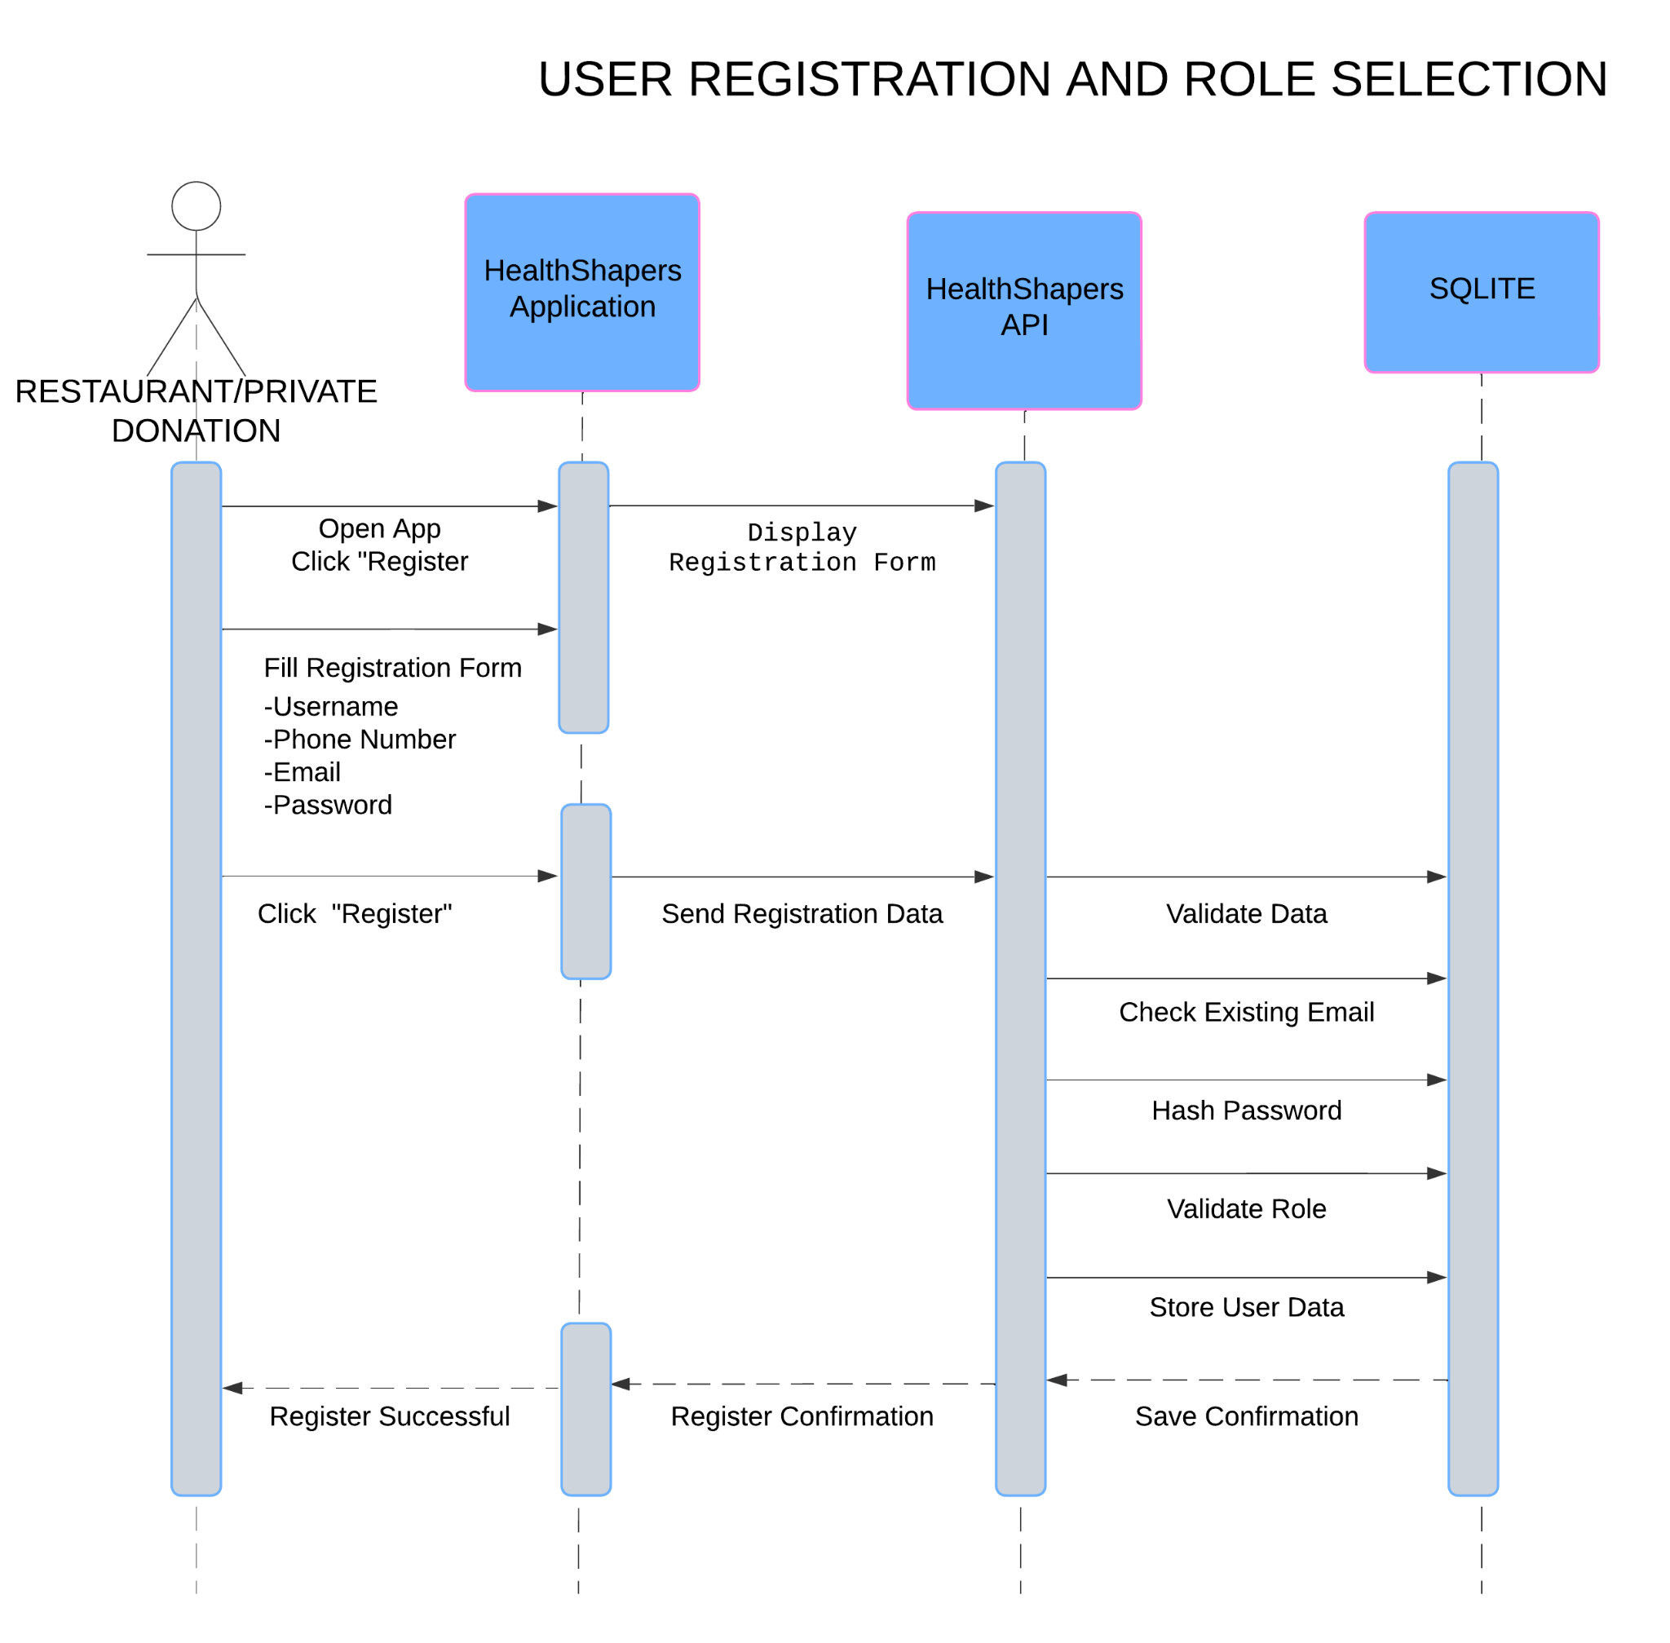

Login Process

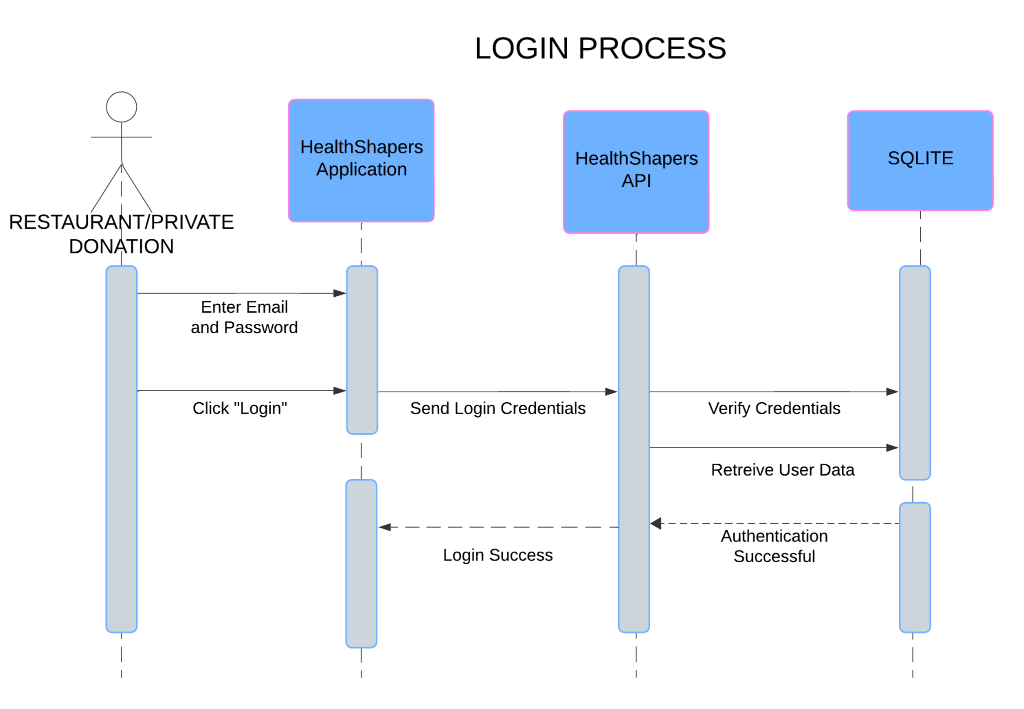

Creating a New Donation

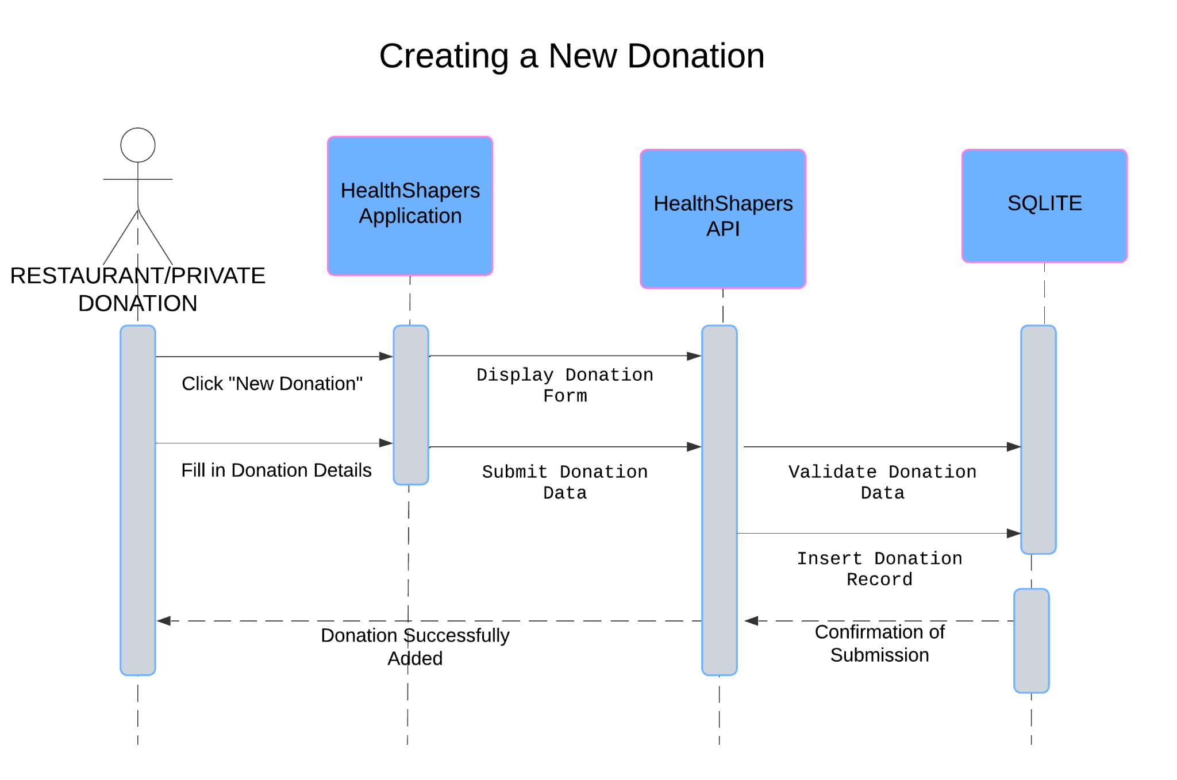

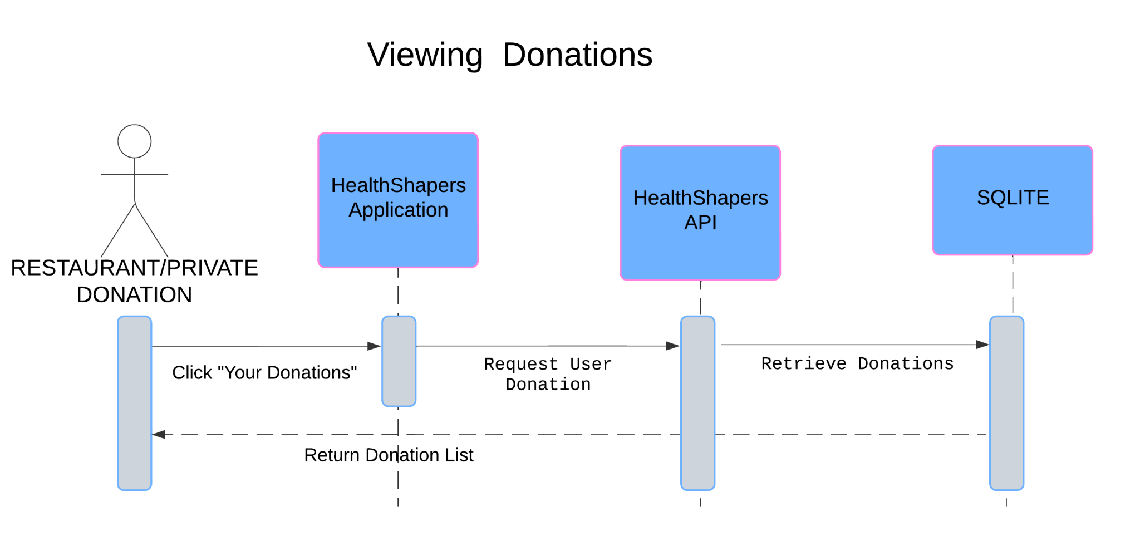

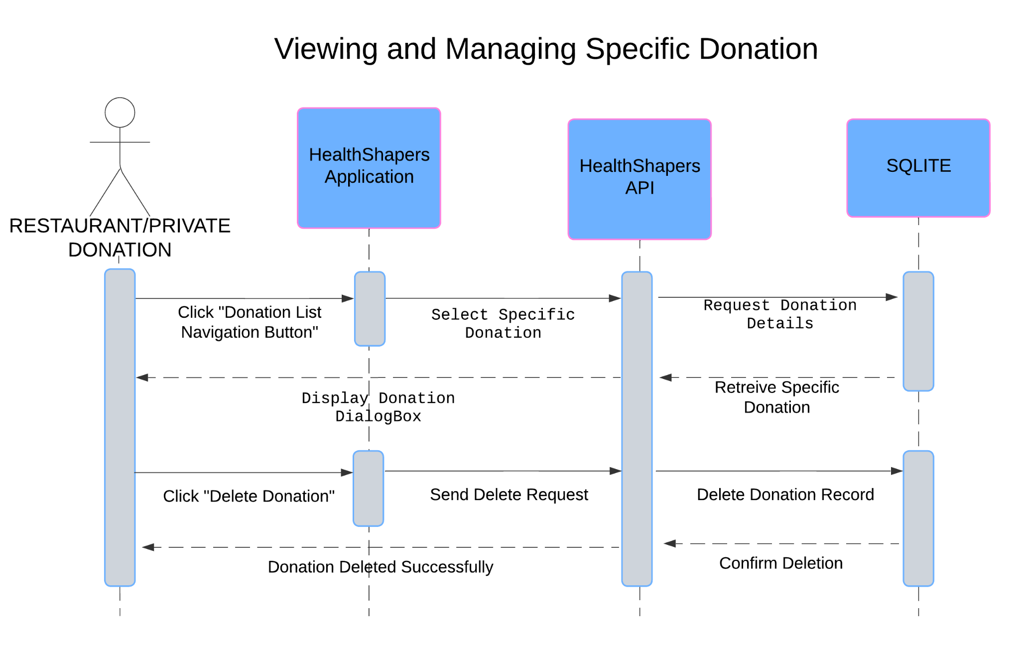

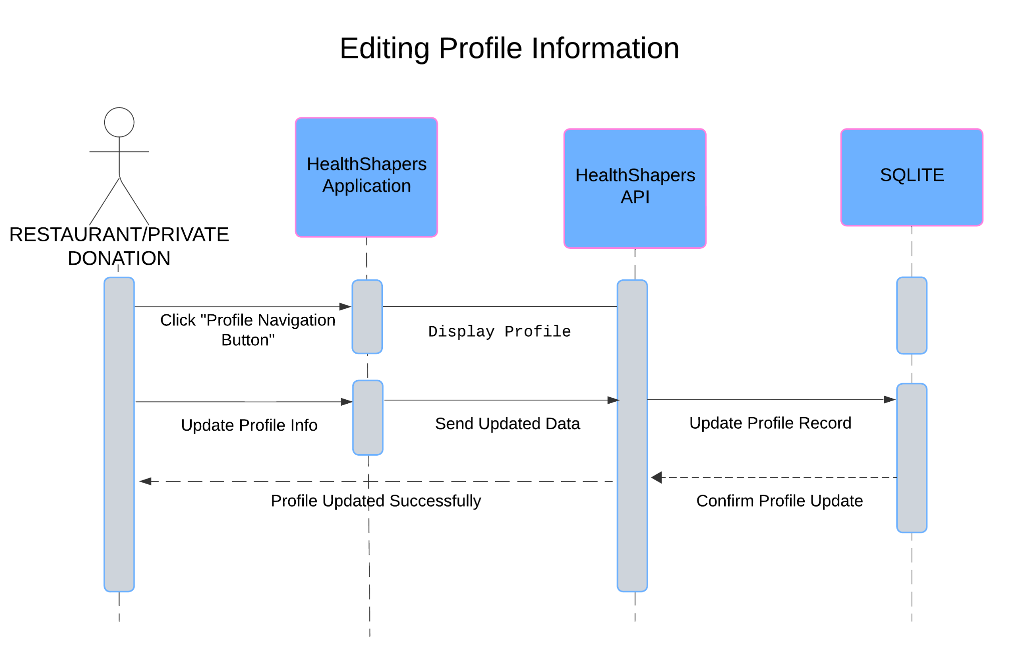

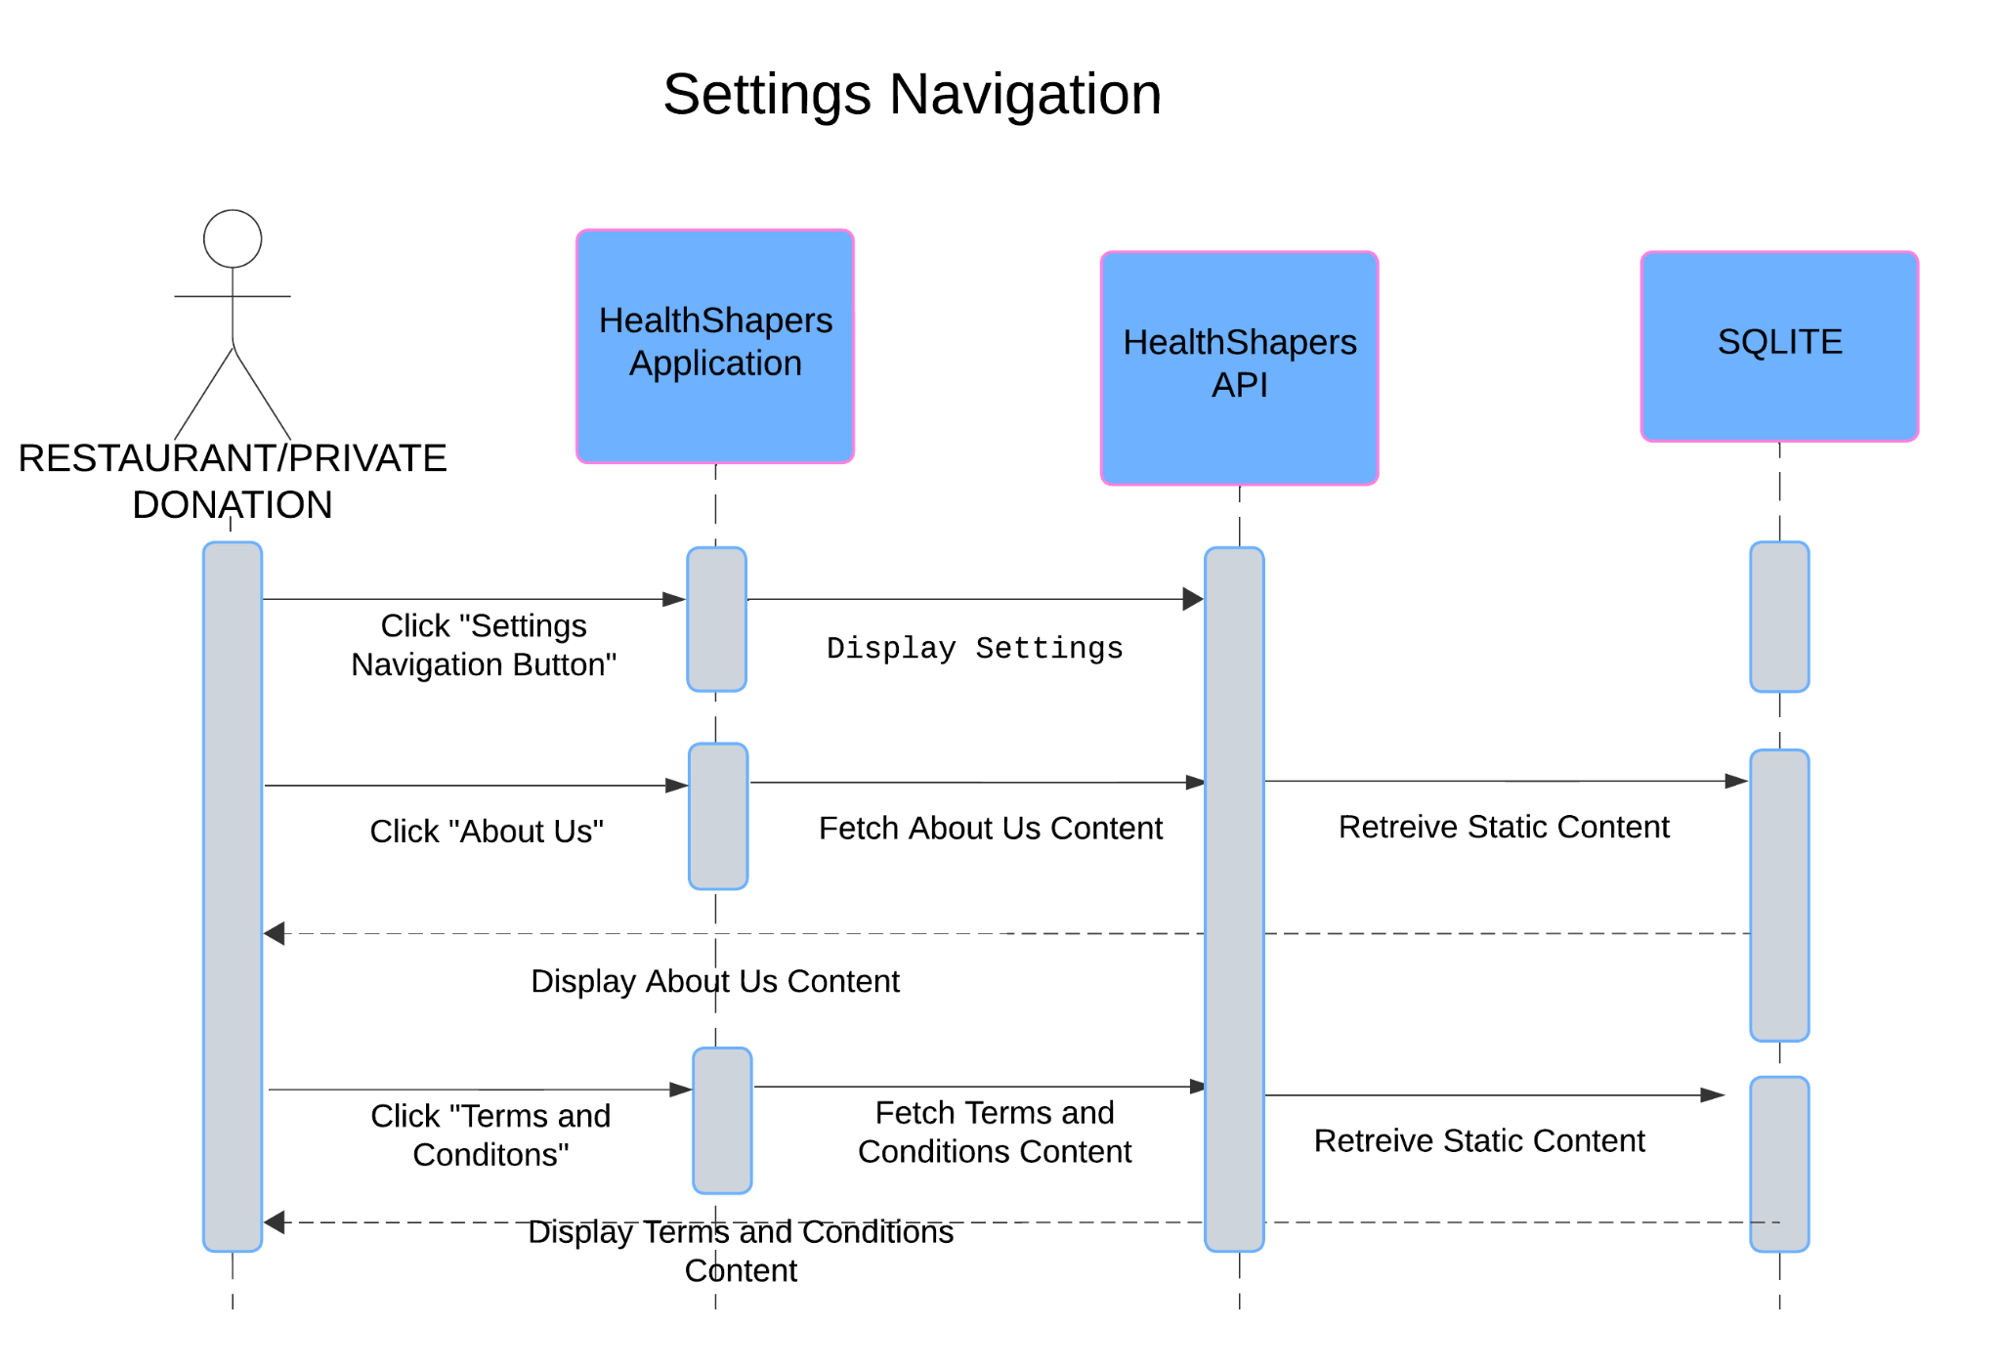

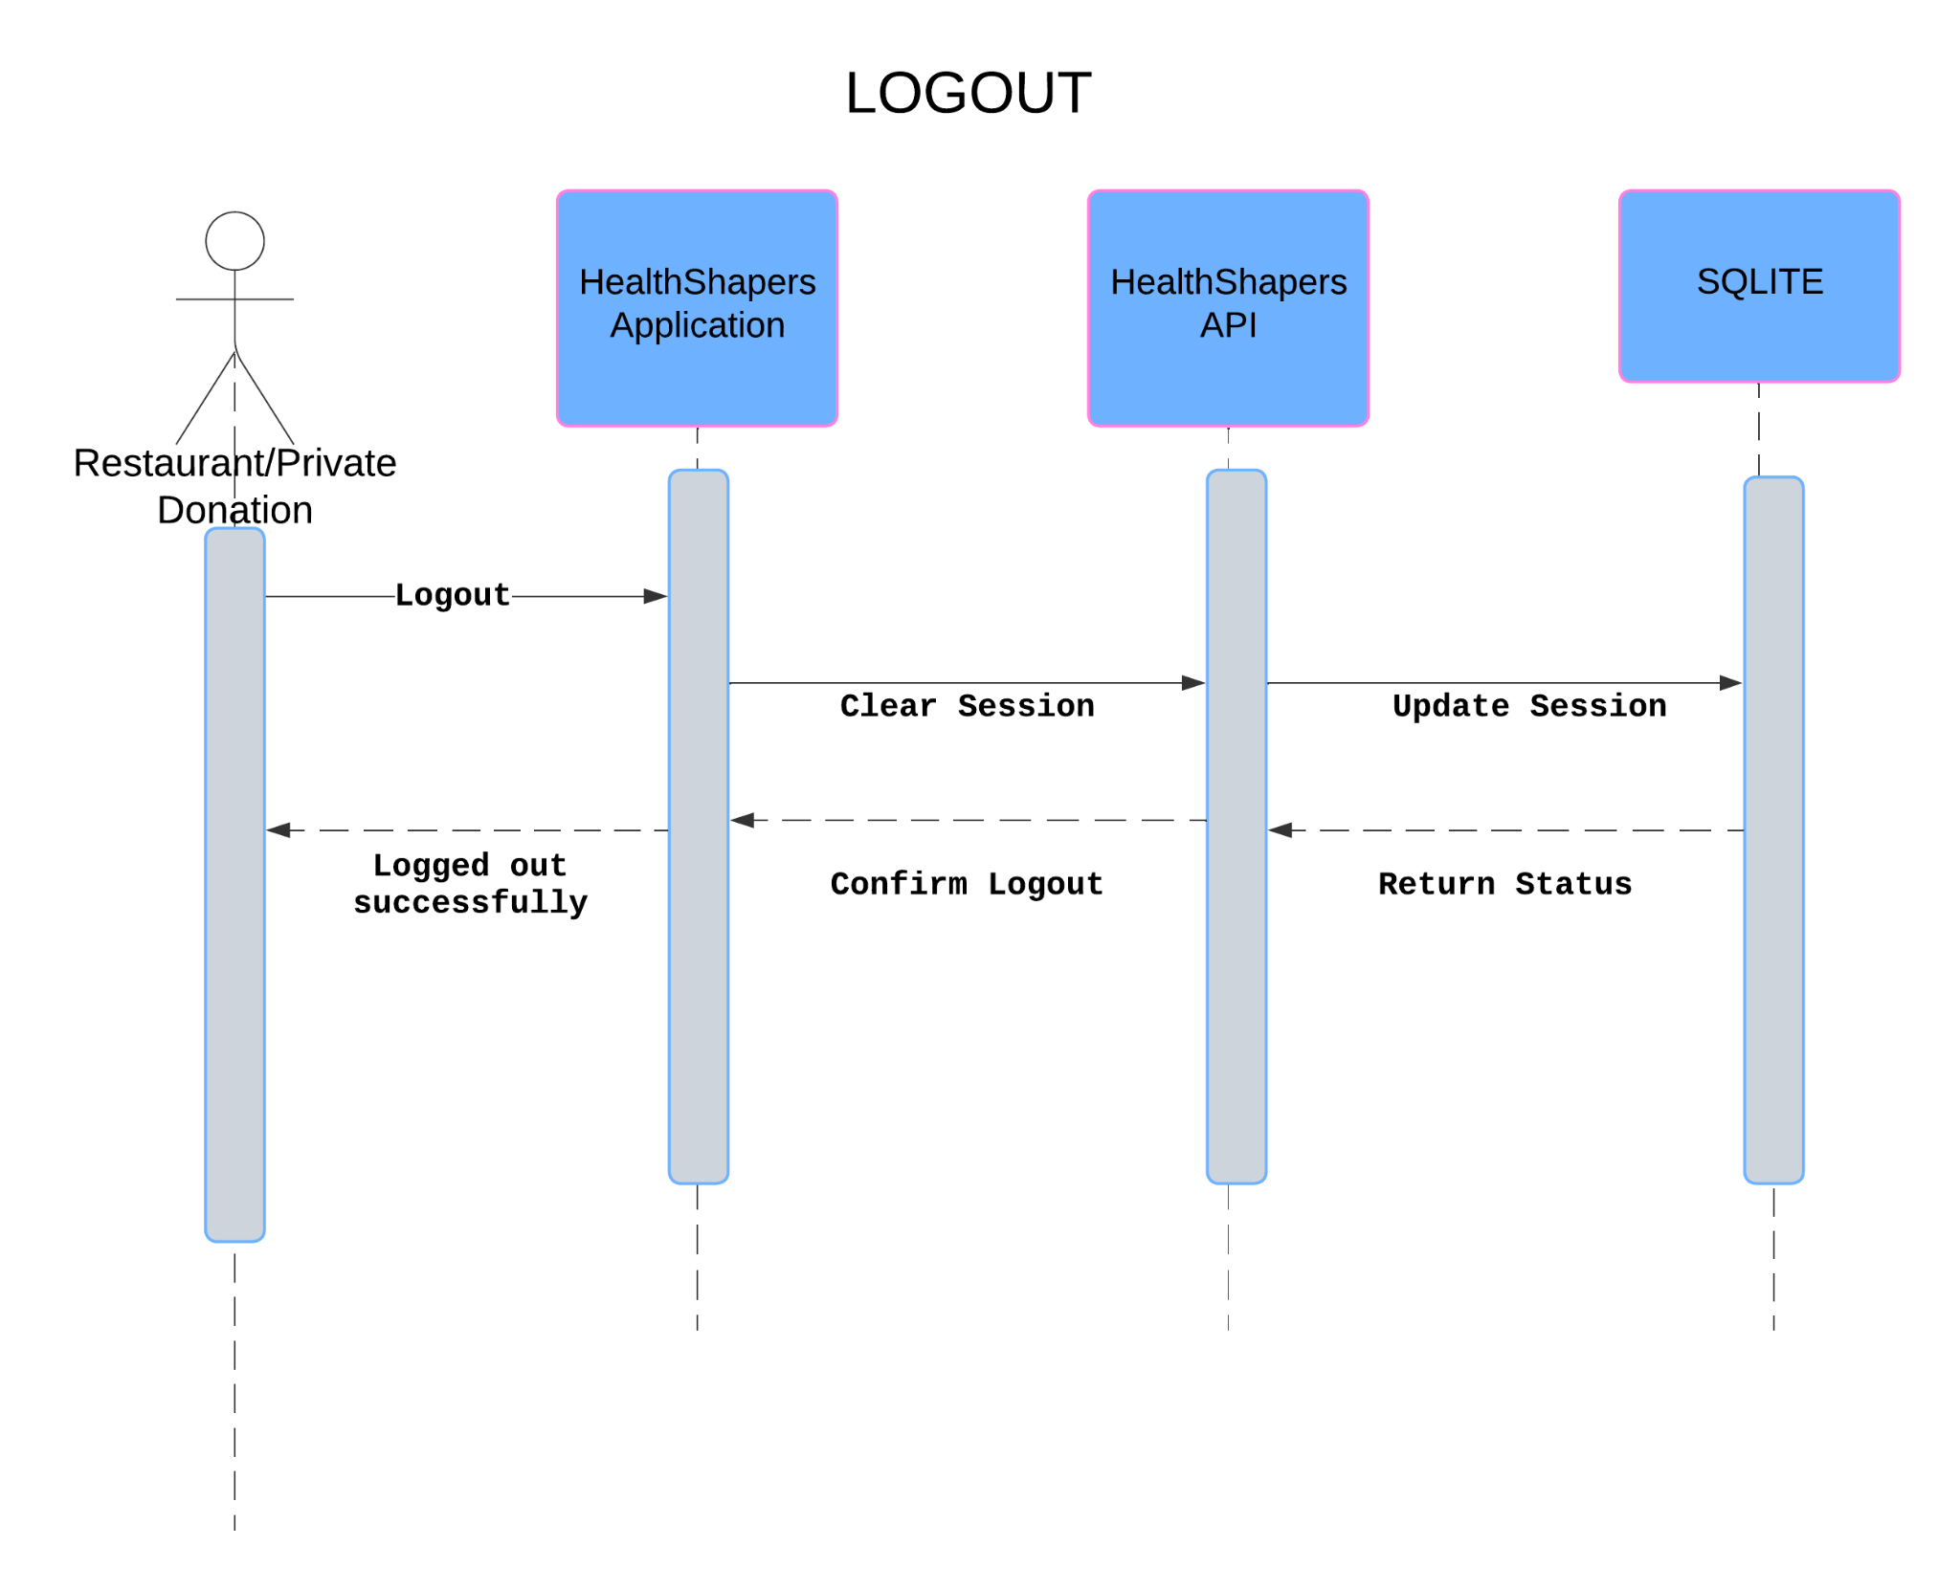

**NGO**

Register

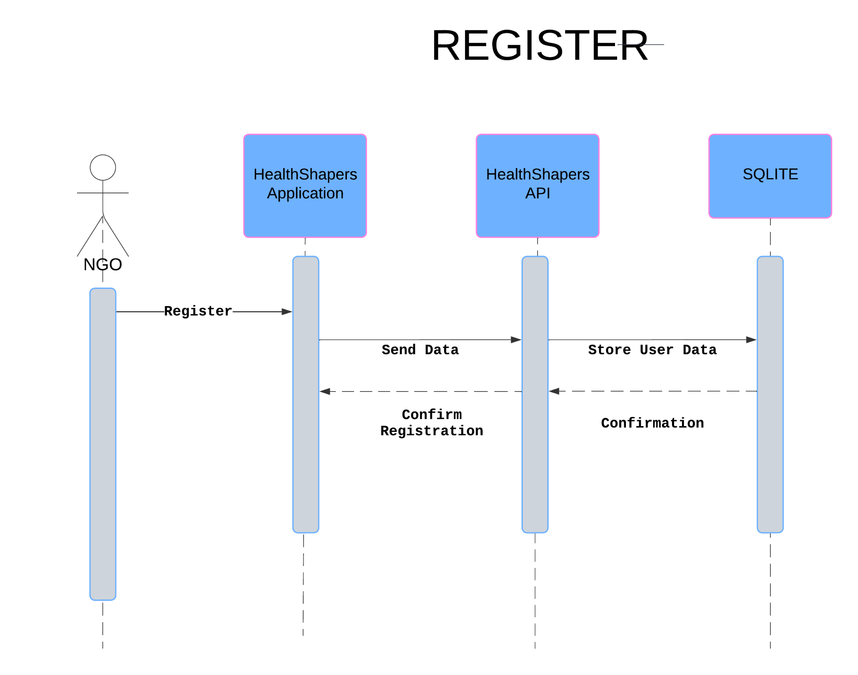

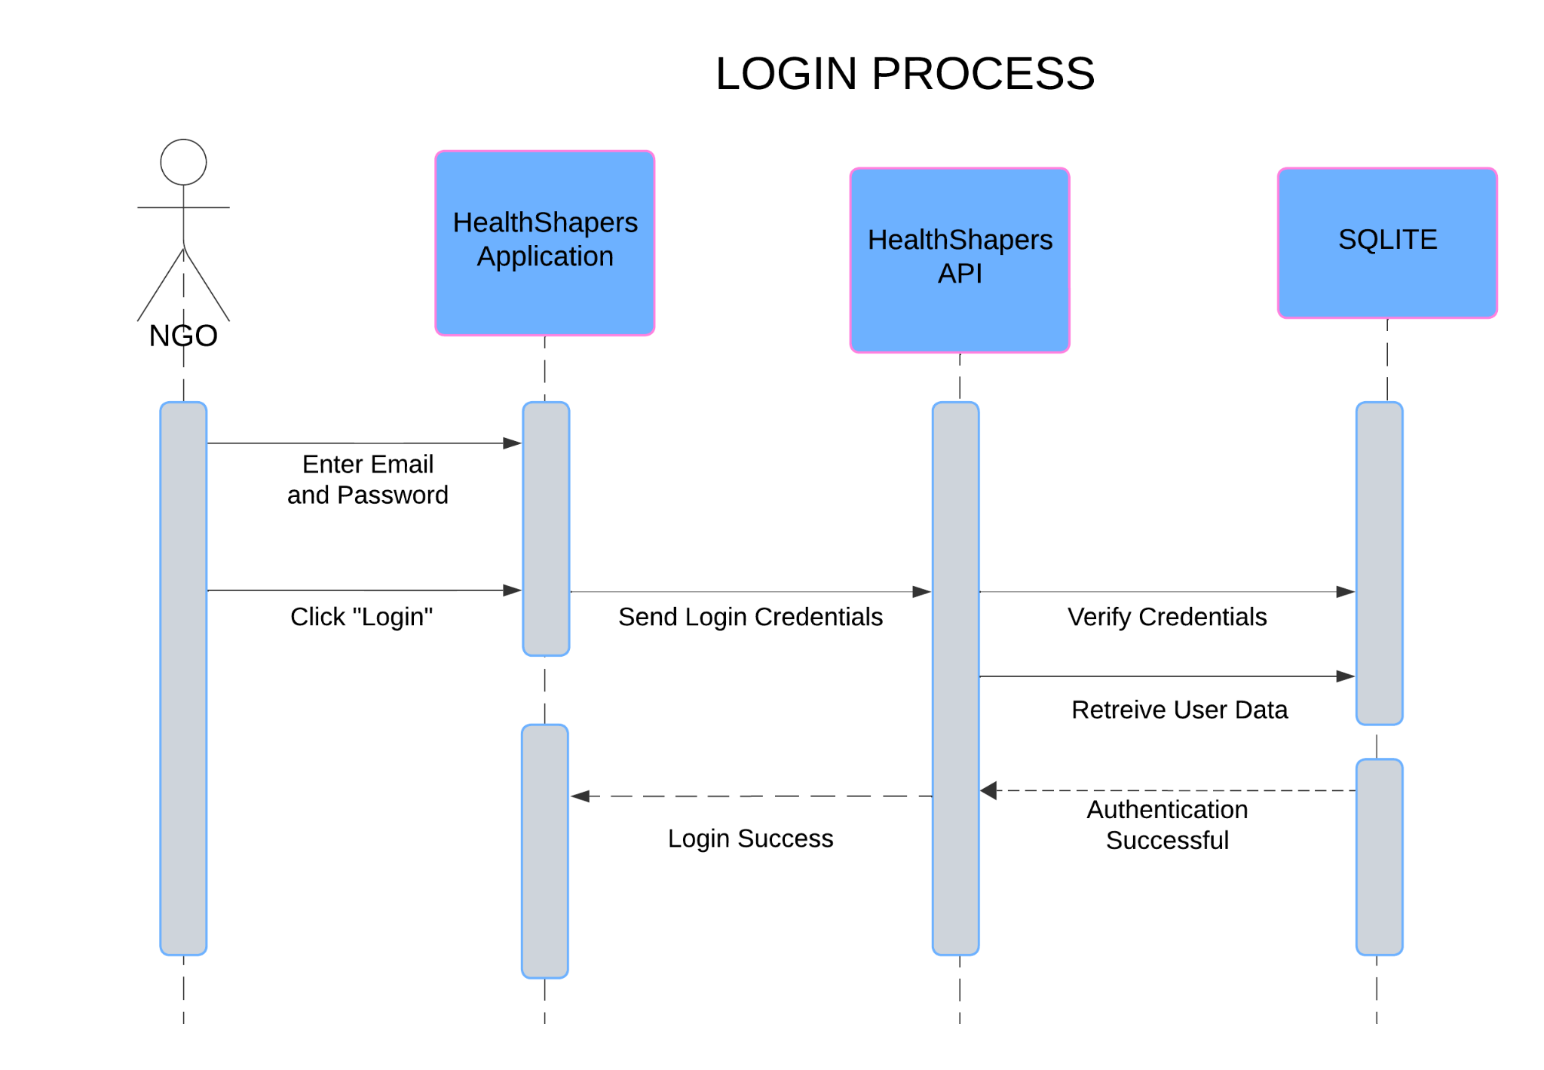

Dashboard

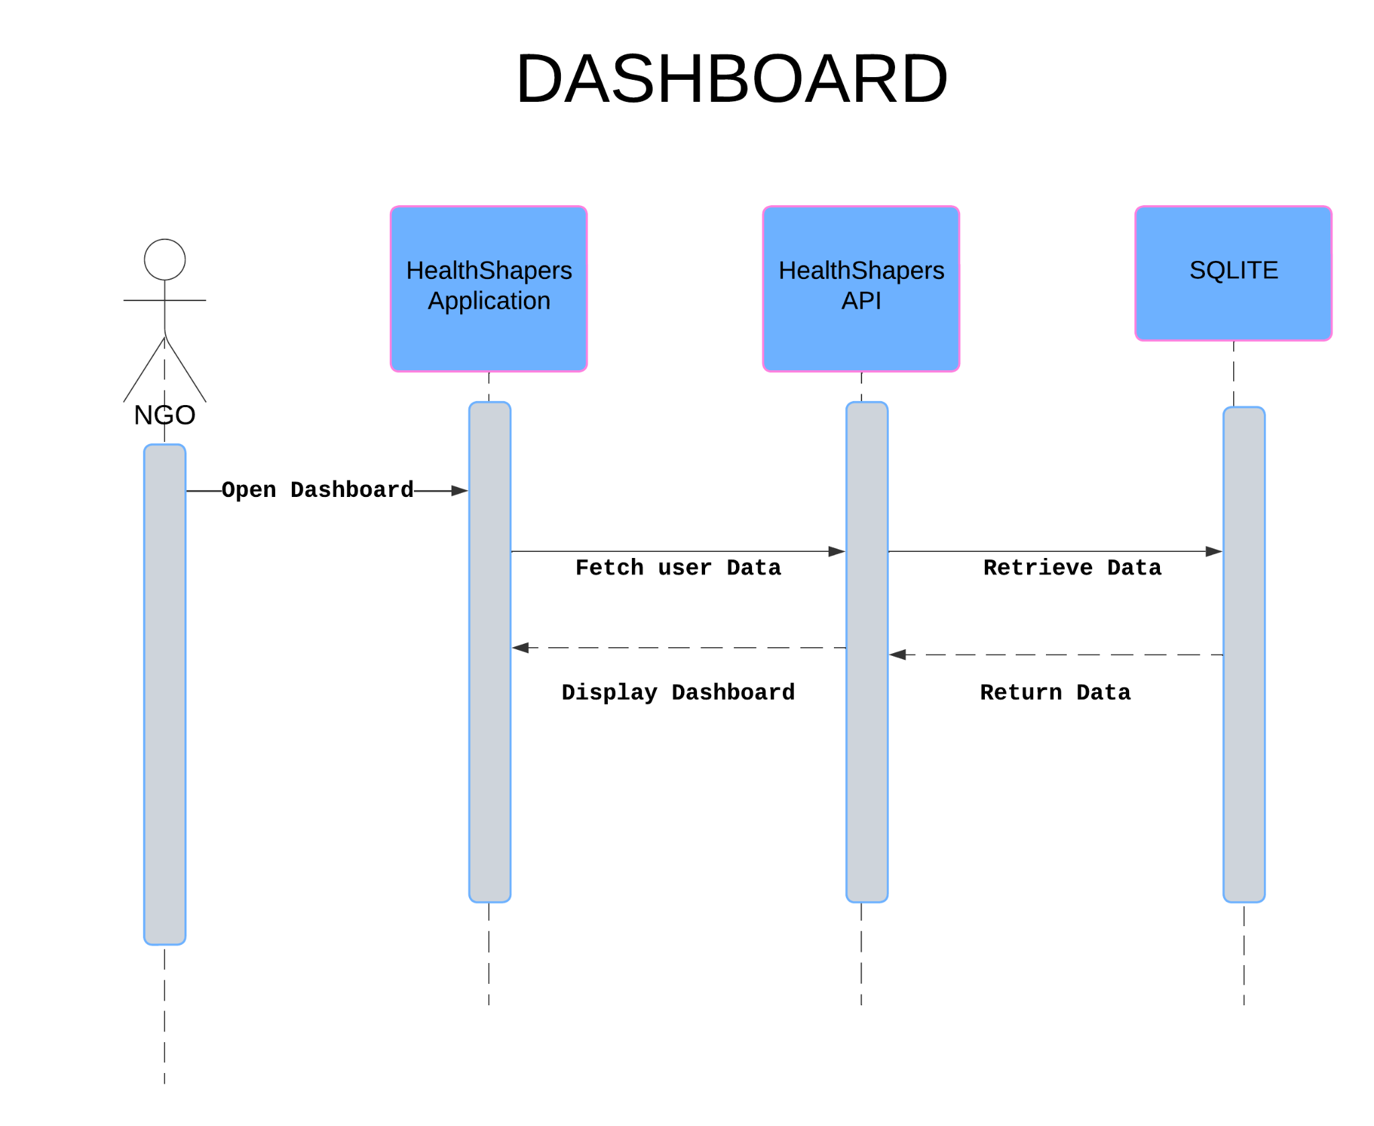

View Donations

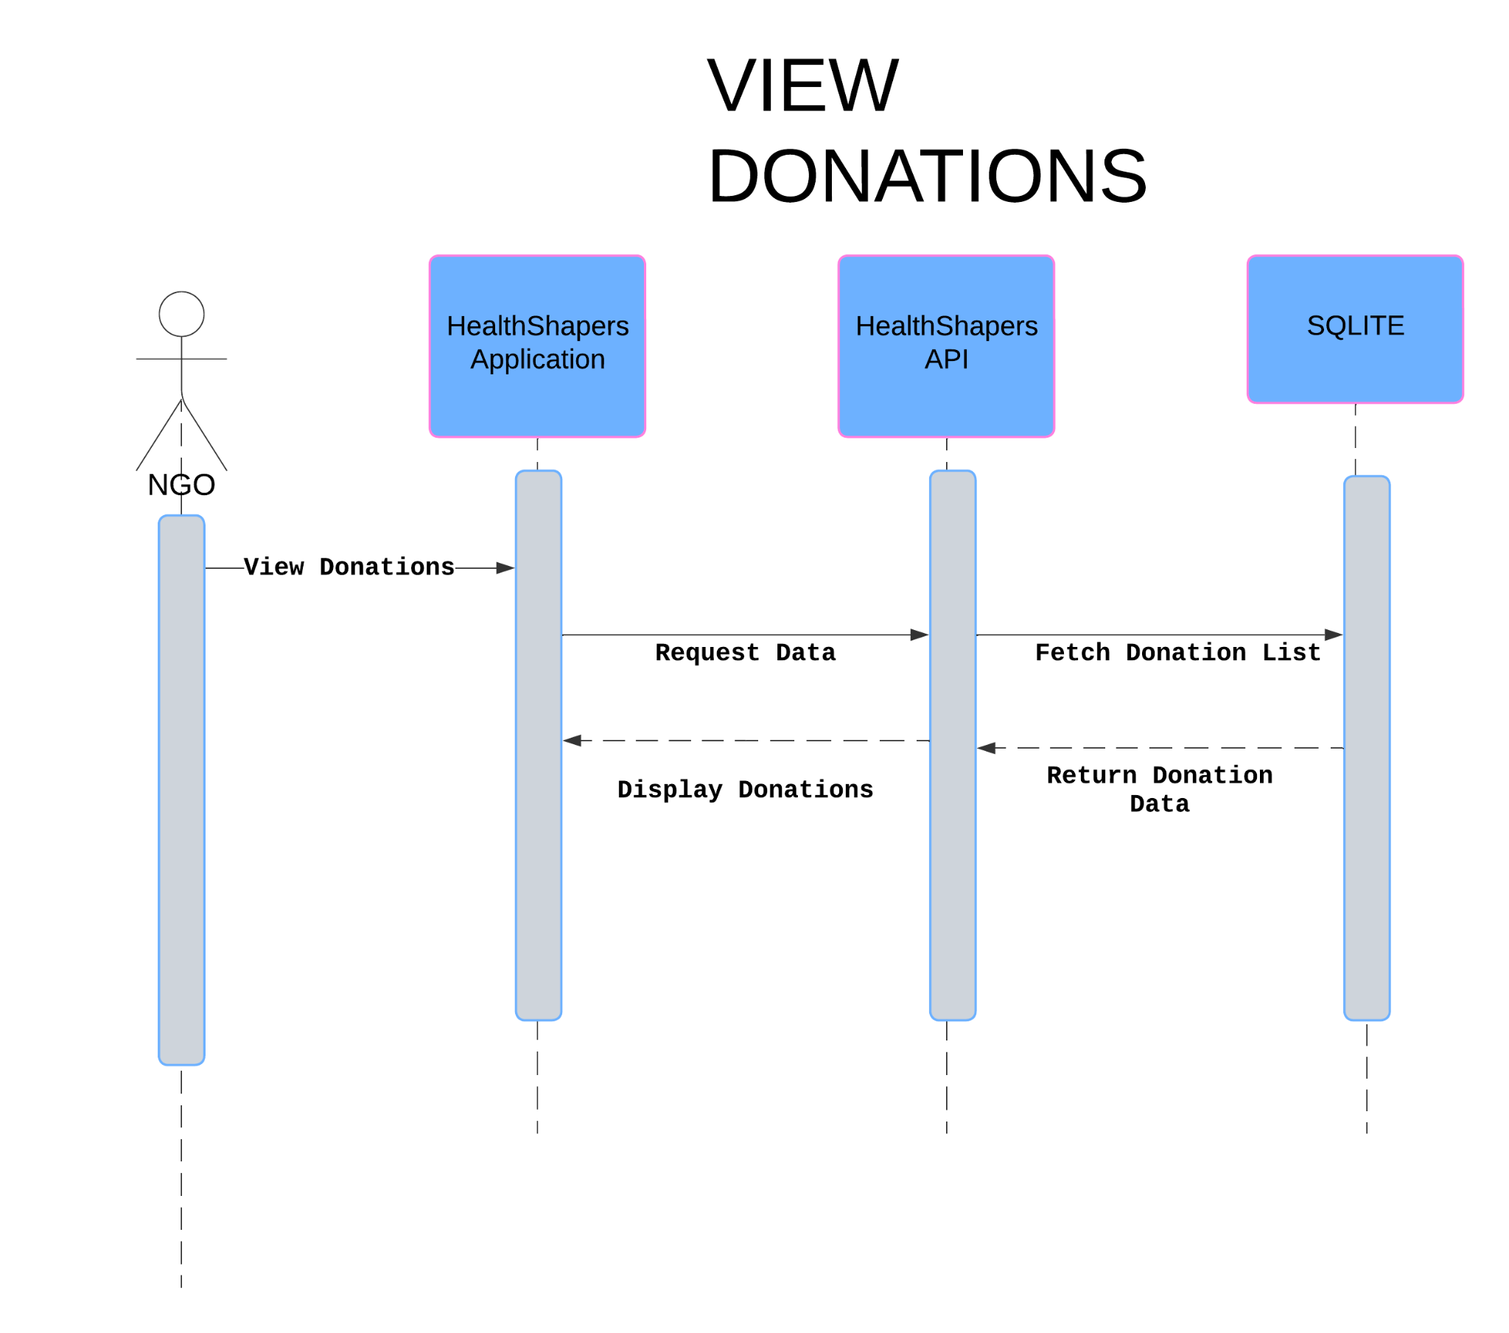

Select Donation

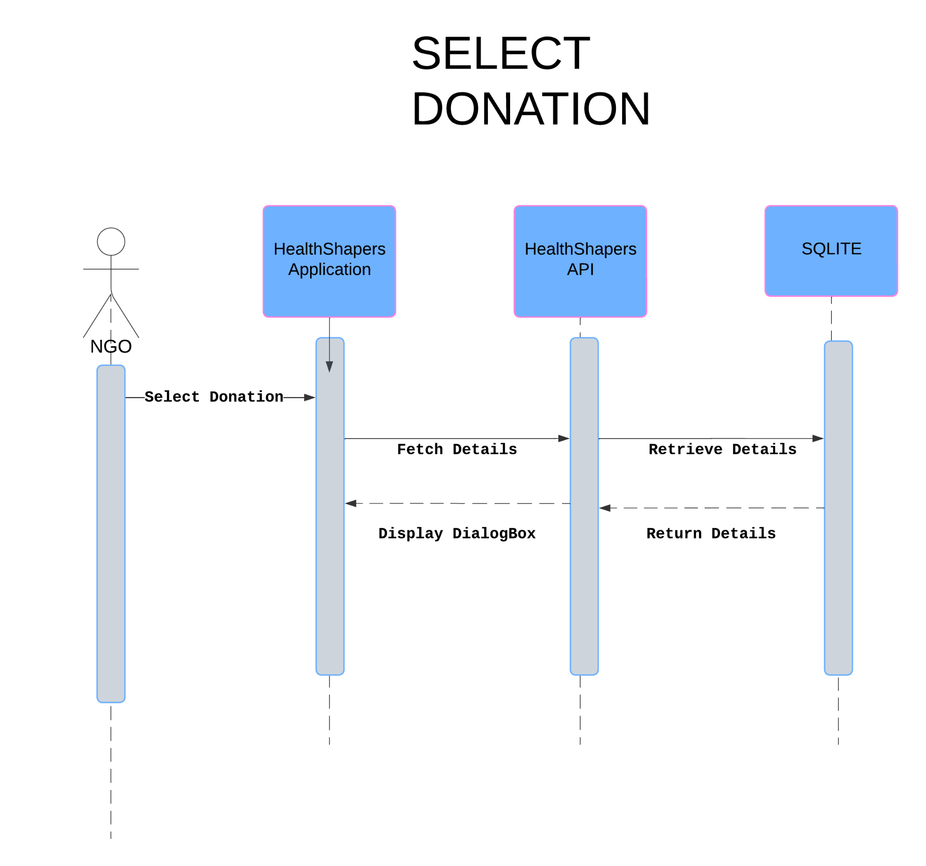

Your Requests

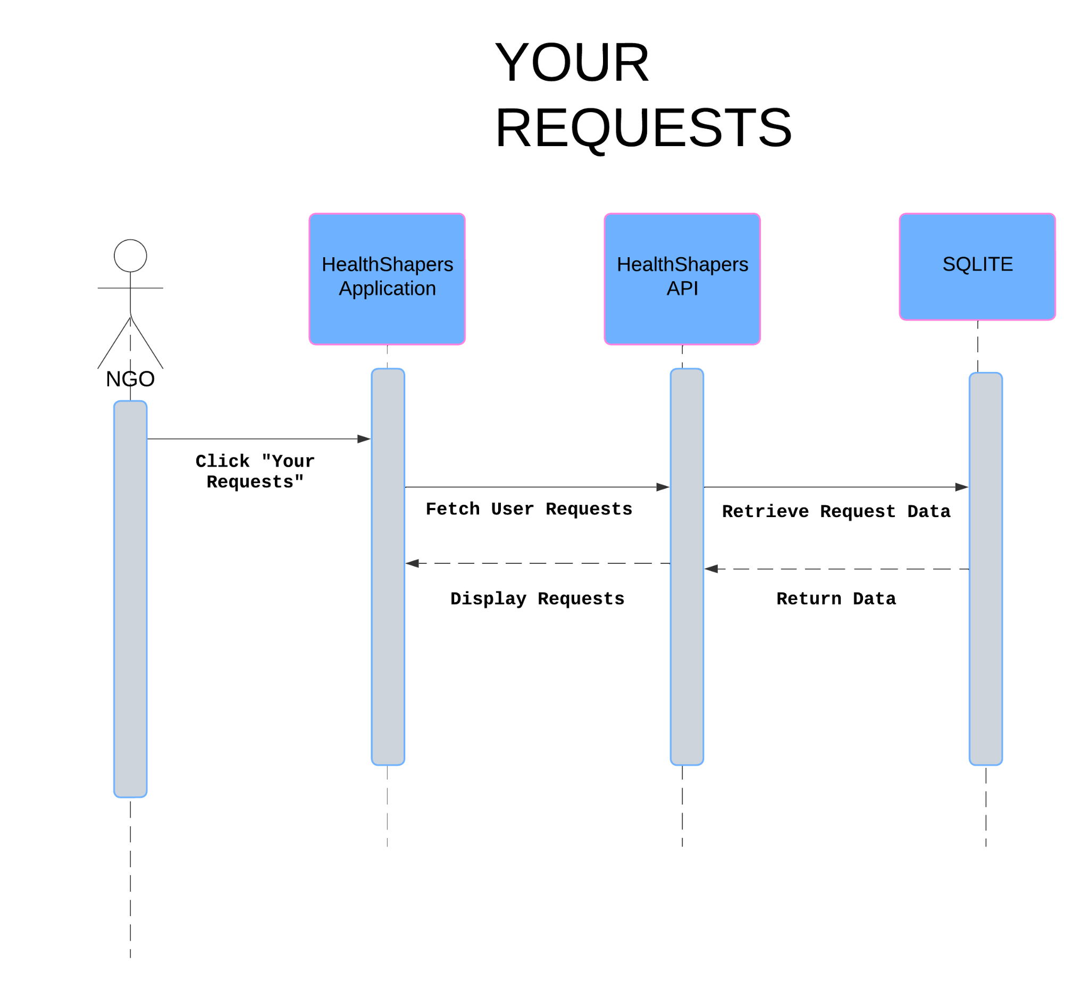

Edit Profile

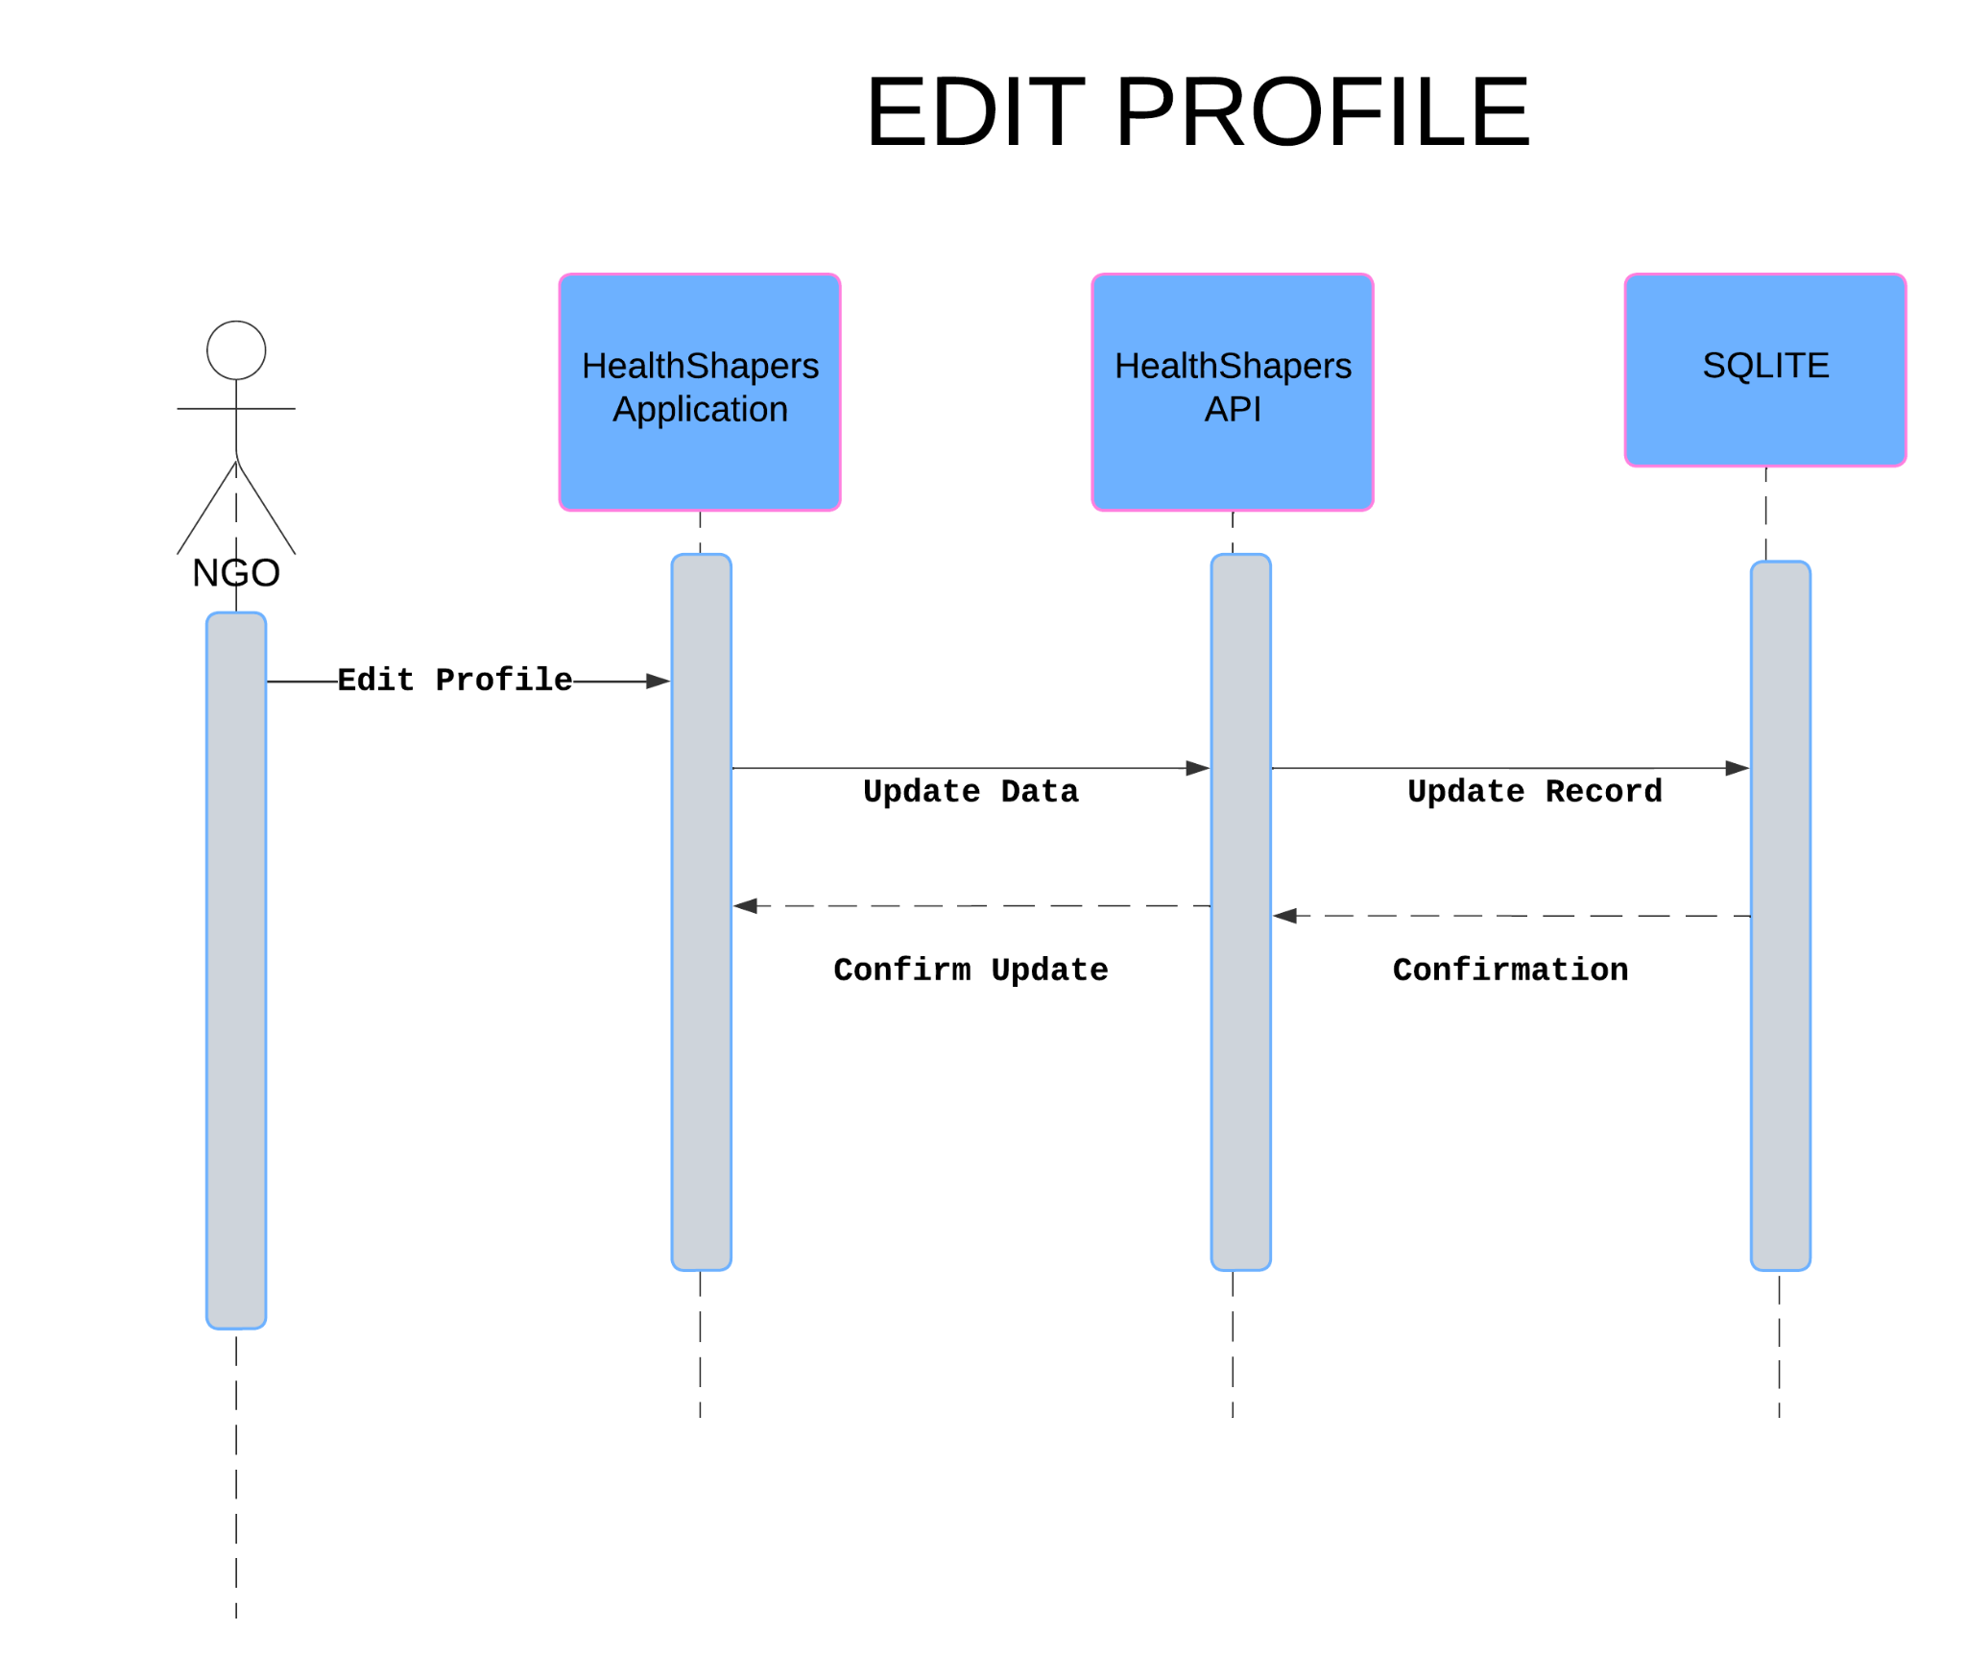

Settings

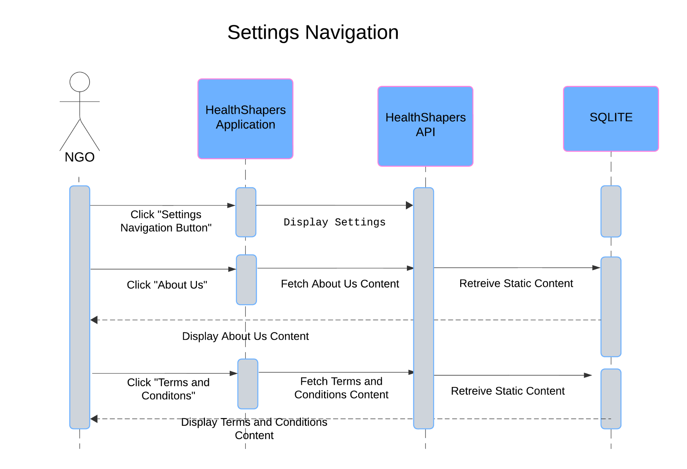

Logout

